**Dataset Description**

This credit card dataset consists of 10,000 datasets for different customers according to their education level, gender, income level, total transaction amount on their credit card, and how long these accounts are on the book. The data is about twenty columns; it shows the spending habits of these customers.

From our dataset, there are two types of customers, the existing customers that continue to open credit card accounts and the attrition customers that cease to exist because they closed their credit card accounts, the credit card companies cancelled their accounts, they had no activity on their credit card.

That data answers questions, such as whether income affects credit card debt, what causes most credit card debt, is credit card debt is worse for those with higher income level or lower income, and if there is a correlation between income, education, and credit card debt.

**Columns**

* CLIENTNUM: this is customer_id
* Attrition_flag: contains existing customer and attrited customer
* Customer_Age: contains customers of different ages.
* Gender: deals with whether the customers are male or female.
* Dependent_count: deals with the number of dependents per household.
* Eductaion_level: deals with the education level of customers whether they are in high school, graduate, uneducated, college, post-graduate, doctorate, or unknown status.
* Marital_Status: deals with the different customer status if they are married, single, divorced or unkown status.
* Income-Category: contains the different income levels for various customers.
* Card_Category: contains the various credit cards and their credit limit.
* Months_on_books: contains how long the credit card balance stayed on the record of the bank.
* Avg_Open_To_Buy: contains the average open credit cards that are used for buying.
* Total_Trans_Amt: contains the total transaction amounts for customers that have credit cards.
* Total_Trans_Ct: contains the total count for credit card transactions.

**Our Analysis:**

* **How does income affect credit card debt?**

From our analysis, we notice that income affects credit card debt. From the charts below, more customer default on their credit cards as their income goes up. From the table below, we notice that there is more credit card debt in customers with higher incomes than customers with lower incomes. Customers with income higher than $120K default about 17.33% than the customers that make less than $40K, they default about 17.19%A graph with orange and blue bars

* **What causes most credit card debt?**

There are so many reasons for credit card debt. One of these causes is that customers pay the minimum on their credit cards, and that is shown in the histogram below:

From that histogram, customers here default on their credit cards, and their accounts age, and in the long run, their accounts stay longer than 44 months on the books. These accounts cause the customers to have a bad credit rating.

Also, there is a strong linear regression relationship between the total count of credit card transactions and the total amount of credit card transactions. That relationship causes the amount and count of credit card transactions to move in the same direction. That means that as more customers open credit cards, they only pay the minimum amount, and that causes their total amount of credit card amount to increase. A graph with blue dots and a red line

* **Is credit card debt worse for those with income greater than $100,000 or with households of lower income?**

In our analysis, we notice that credit card debt is worse for those with lower incomes than those with higher incomes. The lower the income, the more debt customers tend to fall into because those customers spend outside their range; for example, customers that have an income less than $40k have a percentage of 17.19% of credit card debt. Customers with income between $80k to $120k have a percentage of about 15.77%, and their debt proportion falls because they earn more and are more capable than lower-income customers to pay off their debt.

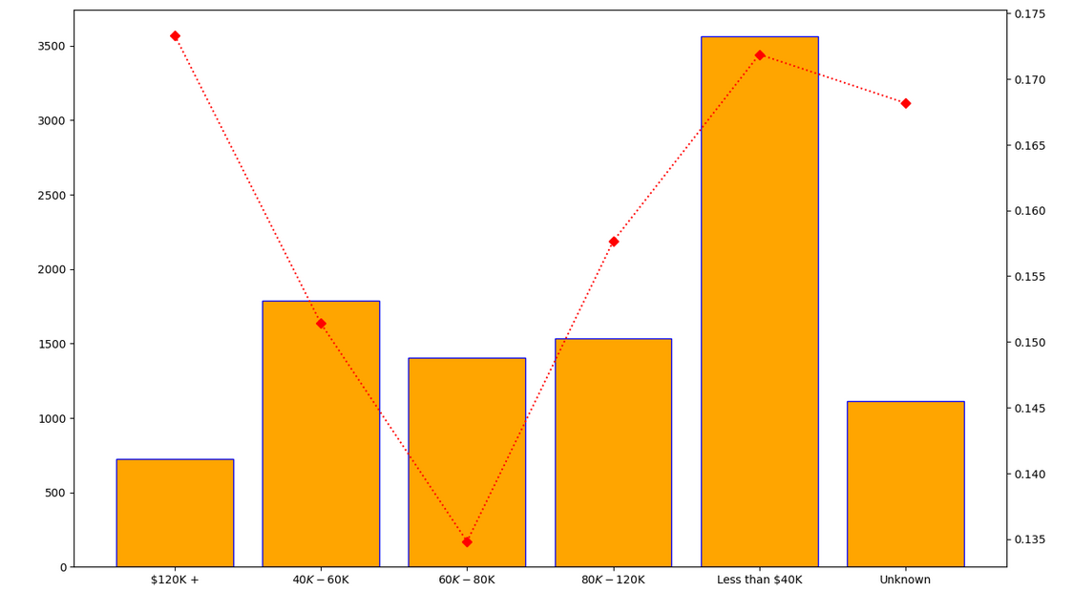

On the other hand, customers with lower income default on their credit cards as their credit card balances stay on the book for almost 44 months, and since they do not pay their credit card bills promptly, they accumulate higher interest rates. For customers with higher income, their balances last for about 36 months, which means they are more capable of getting rid of their credit card debt and paying it off quicker than those with lower income.

* **Is there a correlation between income, education, and credit card debt?**

There is a strong correlation between income, education, and credit card debt. In the relationship between education and credit card debt, customers with graduate degrees default more on their credit card debt than high school, uneducated, college, post-graduate, and doctorate customers. As shown in the bar charts below, the value count for graduates is about 3,128, which is higher than the value count for high school customers, which is about 2,013.

The higher the education, the higher the credit card debt because customers in that situation spend more than other customers. That is shown in the pie chart below, the graduate students spending is about 30.89% value counts for credit card debt which is higher the spending of the high school customers that spend about 19.88% and the spending of the uneducated customers that spend about 14.68%. In that pie chart, the smallest value count is for the post graduate customers that spend about 5.10% while the highest value count is for the graduate customers that spend 30.89%.

Furthermore, there is a relationship between income and credit card debt. From our analysis, we see that the income for customers with doctorate degree is about

Works Cited

Knowledge, H. W. (2013, November 11). A Smarter Way To Reduce Customer Churn. *Forbes*. https://www.forbes.com/sites/hbsworkingknowledge/2013/11/11/a-smarter-way-to-reduce-customer-churn/?sh=1d57f8b02c0a